**PROJECT PROFILE**

**ATCHINSON FORD QUICK LANE FACILITY**

**BELLEVILLE, MI.**

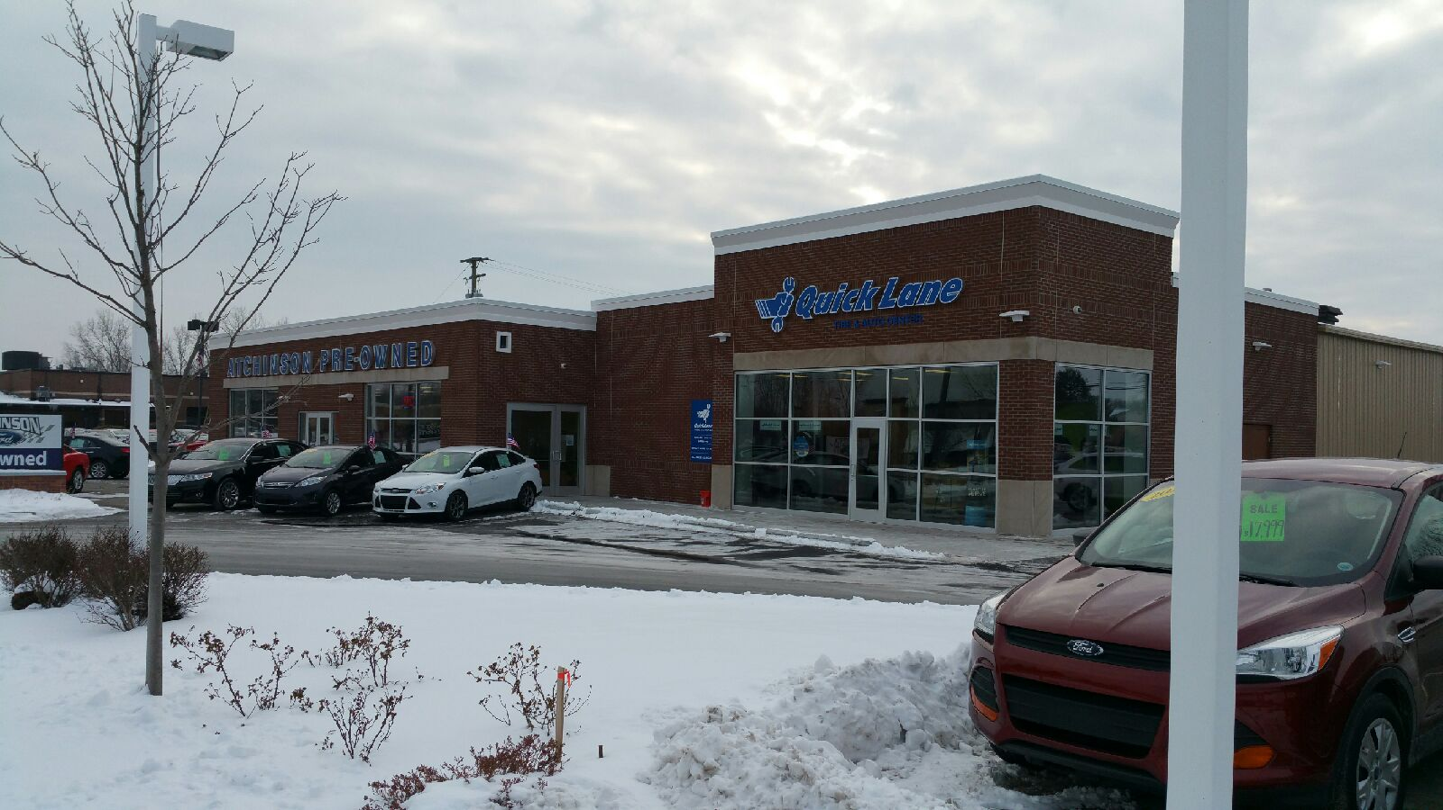

**Perspective:**

This project was constructed for Atchinson Fords

Structural Steel and Masonry Construction

**Owner.……………………..** Atchinson Fords

9800 Belleville, Road

Belleville, Mi. 48111

**Architect.……….…………..**Wayde Hoppe

HOPPE Design, LLC  
47032 McBride  
Belleville, MI 48111

**Service Provided.………….** Construction Manager/General Contractor

**Size….………………………** 3,000 square feet

**Starting Date……………….**March 2014

**Completion............................**October 2014

**Project Cost…………………**$1,300,000.0